# B nDAD 220 Module Five Major Activity Template

## Overview

Review the scenario for this activity in the guidelines and rubric. Then complete the steps below as you work through the directions for this activity. Replace the bracketed text with your screenshots and responses to the prompts. Size each screenshot and its explanation to fit approximately one-quarter of the page with the description written below the screenshot. Review the Template Screenshot Example linked in the guidelines and rubric for this assignment to see an example of how screenshots for your assignment should look.

## Create a Database

1. **Write SQL commands** that capture specific, usable data that can be used in your analysis.
   1. **Reference notes for this step:** Import the CSV file into MySQL Table. Use the following line terminators when importing: \r\n. Do not use IGNORE 1 LINES for data that does not have column headers in the first row.
2. **Analyze the results of queries** to identify specific information that can be presented in your summary.
   1. Sales by region:
      1. Analyze sales data by state to determine where the company has the largest customer base.

Massachusetts is clearly has the top sales number according to the database data with 982 products sold. Arkansas is second with 854 and West Virginia is third with 843 products sold.

* + 1. Analyze the data to determine the top three products sold in the United States.

The top products sold in the United States are as follows BAS-48-1 C (8385 sold), ENT-48-40F (6186 sold) and ENT-48-10F (4329 sold).

* + 1. Analyze the data to determine the top three products sold in the southeastern region of the United States.
* Southeastern states to include in your analysis: Virginia, North Carolina, South Carolina, and Georgia

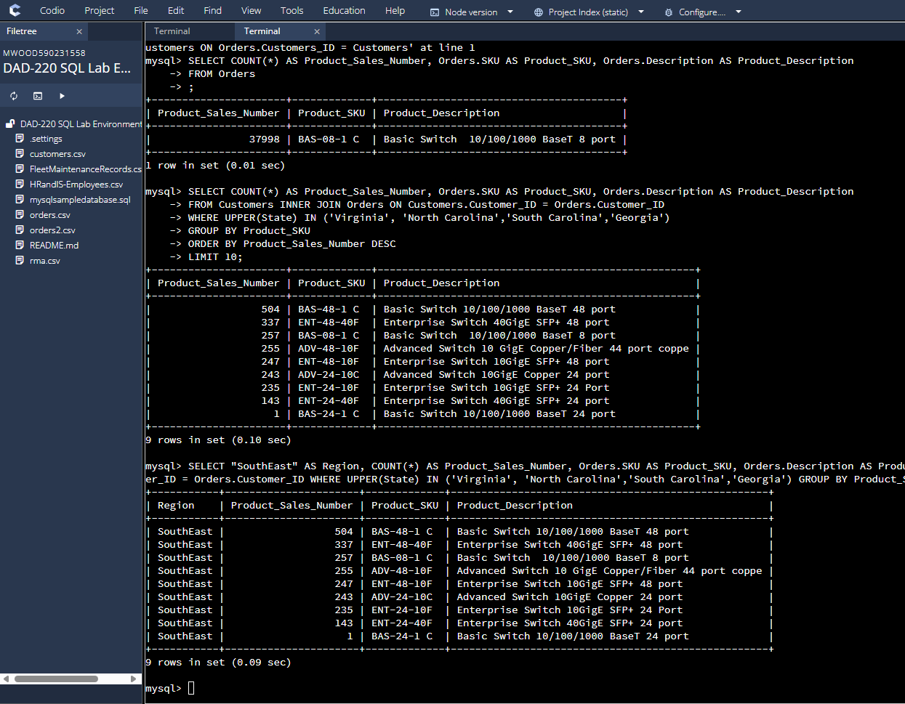

The top three products sold in the South East are the Basic Switch 10/100/1000 BaseT 48 port (504), Enterprise Switch 40GigE SFP+ 48 port, (337), and the Basic Switch 10/100/1000 BaseT 8 port (257).

* 1. Returns by region:
     1. Analyze the data to determine the top three products returned in the United States.

The top three returns are Basic Switch 10/100/1000 BaseT 48 port (7405), Enterprise Switch 40GigE SFP+ 48 port (5470), and the Enterprise Switch 10GigE SFP+ 48 port (3847).

* + 1. Analyze the data to determine the top three products returned in the northwestern region of the United States.
* Northwestern states to include in your analysis: Washington, Oregon, Idaho, and Montana

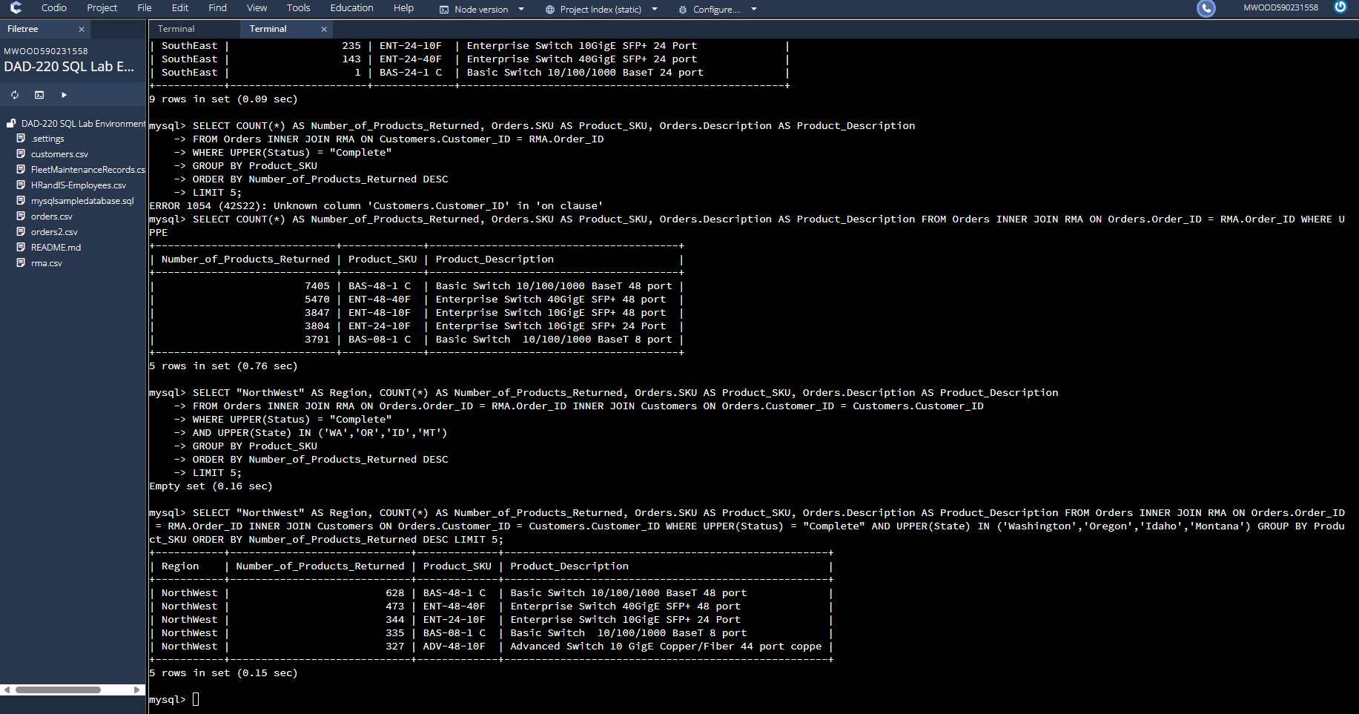

The top three returned products in the Northwest are Basic Switch 10/100/1000 BaseT 48 port (628), Enterprise Switch 40GigE SFP+ 48 port (473), and the Enterprise Switch 10GigE SFP+ 24 Port (344).

1. **Write a report** to the Quantigration product manager that explains your findings in a way nontechnical stakeholders can understand and use.
   1. Provide an effective summary of your findings from the analysis of the sales and returns data you captured. Write at least one paragraph for each of your responses to the prompts below.
      1. Sales data by region: Provide a well-written summary of findings from your analysis in Step Two, Part A.

We used an inner join to mix data from the Customers table with the Orders table based on the Customer ID number. This helped us find the state with the most sales. We then used the Orders table to find the top three products sold in the US by searching by SKU number. We were able to narrow our results even more by combining the Customers table with the Orders table to choose the region we wanted to see and see the sales in that region. As a result, we learned that BAS-48-1 C and ENT 48-40F are the two most popular goods in the United States and the Southwest region.

* + 1. Returns data by region: Provide a well-written summary of findings from your analysis in Step Two, Part B.

The top three most popular items in the US are the Basic Switch 48 port, which sold 8385 units, the Enterprise switch 48 port, which sold 6186 units, and the Enterprise switch 10Gig 48 port, which sold 4329 units. But 7545 of the 8385 BAS-48-1 C (Basic Switch) were sent back, which is about a 90% return rate. Next, 5565 of the 6186 ENT-48-40F switches were sent back, which is also a very high rate, and finally, only 905 of the 4329 ENT-48-10F ports were sent back, which is only about a 20% return rate compared to the other products.